OFFICIAL COORDINATION REQUEST FOR
NON-ROUTINE OPERATIONS AND MAINTENANCE

COORDINATION TITLE- 12JDA12 JDA-N ROV inspection
COORDINATION DATE – 22 May 2012
PROJECT- John Day Dam
RESPONSE DATE- 30 June 2012

Description of the problem – Due to fishway entrance undermining, the JDA North Fish Ladder (JDA-N) entrance improvements contractor requests a ROV inspection of the JDA-N entrance. The information from the entrance inspection will be used to inform design decisions for JDA-N entrance improvements (2012-2013 IWW period).

Type of outage required- Similar outage as required for annual mid-season ROV inspections; AWS flow would be throttled back.
In addition, spillbays 2 and 3 (north) will be closed temporarily (up to 4 hours) to facilitate ROV inspection immediately outside the JDA-N fishway entrance. This will require a temporary change in the spill pattern to move flow to spillbays south of bays 2 and 3. As of July 19, the NOAA forecast for JDA inflow was 263 kcfs for total river Q. A 30% spill pattern would result in ~79 kcfs spill. The Corps recommends closing spillbays 2 and 3 and redistributing flow stops 1.5 for Bay 4, 2.0 for Bay 5, 2.5 for Bays 6-10, 2.0 for Bay 11, 2.5 for Bays 12-13, 3.0 Bays 14-16, 2.5 for Bay 17 and 6.1 for Bays 18 and 19. along the remaining spillbays, following the existing pattern, adding flow where the “next bay on” indicates. The recommended pattern would add 0.5 stops to the existing spill pattern in the following spillbay order: 15, 16, 10, 8, 14, 9, and then 6 as needed. This should minimize impacts on tailrace egress of downstream migrants.

Impact on facility operation – This operation would take the north fishway out of FPP criteria, however, the goal is to overlap this ROV inspection with the planned mid-season ROV inspection to minimize passage impacts. There would be an additional half-day outage of the AWS and a temporary change in the spill pattern.

Dates of impacts/repairs –JDA South Fish Ladder (JDA-S) AWS flow will be reduced for about five hours on 1 August for diffuser grating inspection. The inspection usually occurs in the morning.

JDA-N operations will be impacted for about 8 – 10 hours on 2 August. This includes routine ROV inspection of diffuser gratings as well as the additional ROV inspection of the entrance. A temporary spill pattern will only be used for as long as necessary from 1400 – 1800 to complete the entrance ROV inspection (no longer than 4 hours and likely to take about 2 hours) and will be timed to minimize impacts on upstream and downstream passage.

Length of time for repairs – Total impacts for both ladders would be 1.5 days.

Expected impacts on fish passage –
Downstream migrants- This operation will coincide with the latter part of subyearling Chinook outmigration. The 10-year average (1999-2009) outmigration timing at JDA suggests that approx. 95% of subyearling Chinook typically pass JDA by August 4. The 2012 outmigration of subyearling Chinook began later than average. The temporary (no longer than 4 hours) spill pattern change may result in recirculation in the tailrace, which would negatively impact tailrace egress conditions for downstream migrants for the duration of the operation.

Upstream migrants- There will be one fully functional fishway operating at all times, so migration delays should be minimal. Impacts on adult salmonids are expected to be minimal since the mid-season ROV is scheduled for the time of least impacts on adult salmonids (between summer and fall runs). The timing of this operation does coincide with the historical peak in Pacific lamprey passage at JDA (mid-July to early August), so upstream passage of lamprey may be temporarily delayed.

Comments from agencies

JDA Fisheries -----Original Message-----
From: Zyndol, Miroslaw A NWP
Sent: Monday, June 18, 2012 9:11 AM
Subject: RE: 12JDA12 JDA-N ROV inspection_revised.docx (UNCLASSIFIED)
It should be doable to limit this change of spill pattern to 4 hrs, assuming that the ROV job itself is 2 hrs(?)
After looking at the JDN adult passage distribution, I suggest that we schedule this outage for 1400 hrs through 1800 hrs (typically, more fish are passing during AM hours.) Thanks! MIROSLAW A. ZYNDOL

NWP PM-E----- Original Message -----
From: Tackley, Sean C NWP
Sent: Monday, June 18, 2012 09:56 AM
Subject: RE: 12JDA12 JDA-N ROV inspection_revised.docx (UNCLASSIFIED)
The 1400-1800 hrs recommendation works for me. Thanks! Sean

NWP Dive Safety -----Original Message-----
From: Manny, D. Todd NWP
Sent: Monday, June 18, 2012 10:30 AM
Subject: Re: 12JDA12 JDA-N ROV inspection_revised.docx (UNCLASSIFIED)
The 1400-1800 works for Dive Safety as well. We should be able to complete the inspection within 2 hours. Thank you, Todd Manny

2012 June FPOM. 12JDA12 JDA-N ROV inspection. Tackley said the MOC is coming but wanted to provide a heads up to FPOM. The team will attempt to do the inspection on a 30% day. The spill would be shifted to bays south of Bays 2 and 3, as those bays need to be closed or the ROV inspection. The ROV and spill change would take about 3-4 hours. Fredricks said shifting spill isn’t ideal since it will create an eddy and affect adult attraction. Lorz said he is ok with the change in spill patterns for a short period of time. FPOM said look at the diurnal graphs and pick a four hour window to conduct the inspection.

NOAA Fisheries- -----Original Message-----
From: Gary Fredricks [mailto:gary.fredricks@noaa.gov]
Sent: Tuesday, July 17, 2012 5:25 PM
To: Tackley, Sean C NWP
Cc: Mackey, Tammy M NWP
Subject: Re: FW: FPOM: Official Coordination 12JDA12 JDA-N ROV inspection (UNCLASSIFIED)

We were ok with this at the June FPOM meeting and remain so. I think the latest forecast for early August is for flows in the 250 -270 range so you will need to consider that. Let me know if there are any changes due to the higher flows. Thanks for coordinating. Gary

CRITFC- -----Original Message-----
From: Tom Lorz [mailto:lort@critfc.org]
Sent: Monday, July 30, 2012 10:25 AM
To: Mackey, Tammy M NWP
Subject: Re: FPOM: Official Coordination: 12JDA12 JDA-N ROV inspection(UNCLASSIFIED)
thanks for getting this to overlap[p]ed with the ROV.

Final results- Due to higher than expected river flows, this action will go forward as coordinated but with the adjustment to the spill pattern noted below.
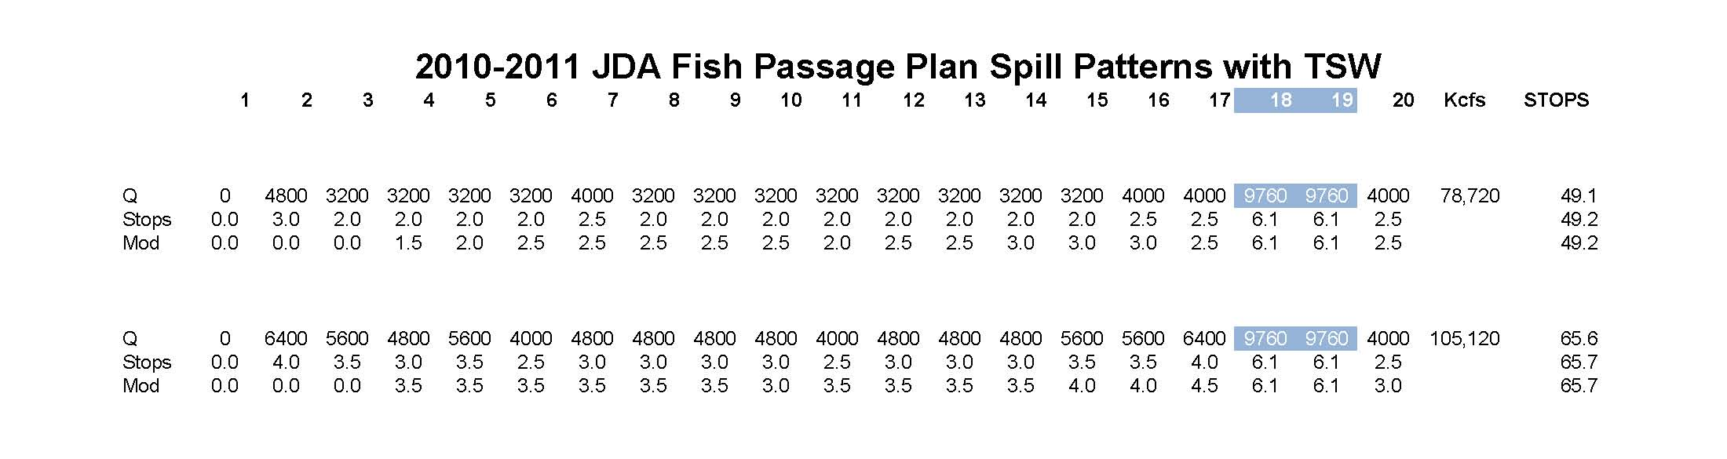

Please email or call with questions or concerns.
Thank you,
Tammy Mackey and Sean Tackley

